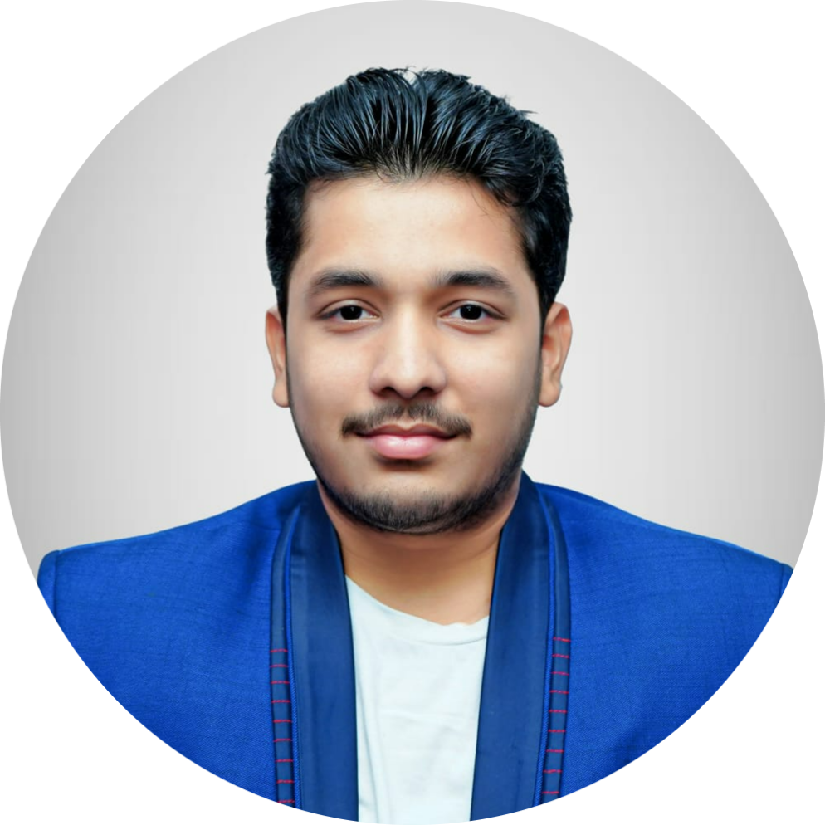**Kowshik Emmadisetty** +91-6302739719

Bachelor of Technology [2100031921cseh@gmail.com](mailto:2100031921cseh@gmail.com) in Computer Science Engineering Github:<https://github.com/Kowshike>

KL University, Vijayawada, Andhra Pradesh LinkedIn:[https://linkedin.com/kowshik-emmadisetty](https://www.linkedin.com/in/kowshik-emmadisetty-3a7874248/)

# Career Objective

Proactive and motivated Computer Science and Engineering student specializing in cybersecurity and web development. Passionate about coding and driven by innovation, seeking to leverage technical skills in a dynamic industry environment.

# Education

|  |  |  |  |  |
| --- | --- | --- | --- | --- |
| **Degree** | **Institute** | **Board / University** | **CGPA/Percentage** | **Year** |
| B.Tech CSE(Honors) | KL University, Vijayawada | KLU, Vijayawada | 9.71 cgpa | 2021-2025 |
| Senior Secondary | Narayana Junior College, Vijayawada | BIEAP | 90.10% | 2019-21 |
| Matriculation | Narayana E.M High School | BSEAP | 90.25% | 2019 |

**INTERNSHIPS**

* **AICTE** *July 2021 - August 2022*

*Intern* Online

* + JUNOS Operating system
  + Network fundamentals
* **Edu Skills Foundation** *August 2022 - July 2023*

*Intern* Online

* + Cloud computing

**PROJECTS**

* **Personal Portfolio** *Dec 2023*

A project that showcases all my projects and work <https://portfolio-kowshik.netlify.app/>

* + Tools & technologies used: HTML, CSS, BootStrap
* **Personal Resume Generator** *Jan 2024 – Mar 2024*

A website designed using React *to generate a resume* <https://kowshik-resume-generator.vercel.app/>

* + Tools & technologies used: HTML, CSS, JavaScript, BootStrap
* **Image Forensics** *April 2024-May 2024*

A website designed using Flask to analyze the image and provide EXIF data.

* + Tools & technologies used: HTML, CSS, JavaScript, Python, Flask
* **Academic Project Management System** *June 2024(ongoing)*

A website designed using Java Full Stack

* + Tools & technologies used: Java Full stack,SpringBoot, HTML, CSS, JS, MySQL

# TECHNICAL SKILLS

* **Languages**: C, Java, Python, SQL, Data Structures and Algorithms
* **Tools and Frameworks**: HTML & CSS, React, Flask, Hibernate, BootStrap
* **Databases**: MongoDB & MySQL

# CERTIFICATIONS

* [**AWS Certified Cloud Practioner**](https://www.credly.com/badges/4fe3f327-8d14-401c-ab86-2d48eb5401a7/linked_in?t=s4xa2e)Amazon Web Services
* **NPTEL Certifications: Demystifying Networks, Ethical Hacking** Swayam
* [**Google Cloud Associate Engineer**](https://www.credly.com/badges/095152d7-b9a9-4472-a86f-278267fe22e2/public_url)Google Cloud Services
* [**RedHat Certified Enterprise Application Developer**](https://www.credly.com/badges/0b2a3aea-ce64-4906-addd-67e9d3c38d44/public_url) RedHat

# EXTRA-CURRICULAR ACTIVITIES

* Conducting cybersecurity workshops for junior students, focusing on network security, data protection, and ethical hacking principles.
* Pencil Arts and Micro Arts
* Social Internship Program at Mursamalli Thanda village.

# CODING PLATFORMS

* LeetCode : [**https://leetcode.com/Kowshikemmadisetty/**](https://leetcode.com/Kowshikemmadisetty/)
* CodeChef : [**https://www.codechef.com/users/klu2100031921**](https://www.codechef.com/users/klu2100031921)

# POSITION OF RESPONSIBILITY

* **Technical lead**, White-Hat Hackers Club, KL University *Mar. 2023*

# ACHIEVEMENTS

* **Miracle-World Record**, Indian National Anthem Carved on a Turdal of size 5mm. *2018*
* Participated in **Codekaze 2023** and ranked 2106 out of 100K+ participants. *2023*